Tesla Motors

MGT 489 W1 winter 2015

[Type the abstract of the document here. The abstract is typically a short summary of the contents of the document. Type the abstract of the document here. The abstract is typically a short summary of the contents of the document.]

2015

Aaron Budnick, Corey Cunningham,

Kerrene Davidson, Logan DeanDeborah Ferguson

4/6/2015

Contents

EXECUTIVE SUMMARY Page 2

STAKEHOLDER ANALYSIS Page 3

Figure 1 Page 3

STRENGTHS Page 4

WEAKNESSES Page 5

EXTERNAL OPPORTUNITIES Page 6

EXTERNAL THREATS Page 7

VRINE MODEL Page 7

Figure 2 Page 8

PORTERS FIVE FORCES Page 9

Figure 3 Page 10

VALUE CHAIN Page 11

Figure 4 Page 11

Figure 5 Page 12

Figure 6 Page 13

FINANCIAL ANALYSIS Page 13

Figure 7 Page 15

Figure 8 Page 16

Figure 9 Page 18

STRATEGIC ALTERNATIVES Page 17

NEW VALUE CURVE Page 19

Figure 10 Page 19

Figure 11 Page 20

FINAL RECOMMENDATIONS Page 20

BIBLIOGRAPHY Page 23

**Executive Summary**

Tesla Motors Inc., whose headquarters are located in Pala Alto, California, was founded in 2003 by a group of engineers who wanted to prove that electric cars could be better than gasoline-powered cars. Tesla Motors uses proprietary technology, world-class design and state of the art manufacturing processes to create a new generation of highway capable electric vehicles and advanced vehicle components. Tesla also provides electric vehicle power trains and technologies to partner organizations. The company is worth more than $25 billion, sells cars in thirty seven countries worldwide, and is continuously expanding. (Groom, 2014)

“Our goal when we created Tesla a decade ago was the same as it is today: to accelerate the advent of sustainable transport by bringing compelling mass market electric cars to market as soon as possible.”(Musk, 2013). The hope is to lessen global dependence on petroleum-based transportation and drive down the cost of electric vehicles.

Their current target market is upper class, rich, affluent and green conscientious people looking to own an all-electric sports car.

The Tesla Roadster (introduced in 2008) was the first high performance electric vehicle ever available to the American consumers, the first electric vehicle to travel more than 200 miles on a single charge, and the first ever federally certified lithium ion battery electric vehicle. Tesla has since introduced the Model S, the world’s first premium 100% electric sedan that could go from 0 to 60 in 5 seconds. In late 2014, Tesla unveiled the 85D and the P85D, two dual motor (one motor in the front, one in the rear) all-wheel drive configuration of Model S, which is the fastest four-door production car ever made. Later this year Tesla is preparing to launch the Model X SUV, a crossover vehicle that will feature exhilarating accelerations, falcon wing doors, and room for three rows of seating.

Most car companies create value by creating a car that is slightly better for a specific market; Tesla creates value in their own unique way. Tesla Motors have showrooms around the world that showcase their model lineup and let customers complete the actual sales online. Using these showrooms, Tesla can sell the cars directly to consumers, rather than through dealerships. This approach allows Tesla to maintain the highest levels of customer experience and benefits by the short customer feedback loops. This also, ensures that the customer needs are fulfilled. This model has seen a lot of conflict and resistance, particularly in North America where the dealership model is the norm in the auto industry.

As Tesla broadens its product line from the upscale market niche of EV’s to include the mass market segment, they need to increase productivity. The drawback is the availability of the Lithium-ion battery cells. Tesla has plans to finish a Gigafactory, which by 2020 will have the capacity to build 500,000 lithium-ion battery cells, more than the current total world production. This factory will help tesla diversify its main revenues sources, something that is necessary to increase profitability and compete with the established car companies. With this they will have the larger market share of electric vehicles, by being the dominant supplier of the battery packs and powertrain components.

**Stakeholder Analysis**

The stakeholder’s analysis chart identifies the key players that have influence on the overall direction of the company. This is broken down into four groups; Organizational, Capital Management, Product Management, and Social. Elon Musk is the most influential leader on of the company. He is a visionary and is committed to making a difference in the world. By his side is a group of executives with years of experience from various automobile companies and tech companies like Google and Apple.

Tesla’s biggest partner is the Japanese battery supplier Panasonic. Recently they agreed on a partnership to build and run the largest battery production factory aimed at increasing the availability and affordability of electric vehicle batteries. They also worked with Daimler in a partnership ever since their IPO in 2010. They had teams that worked together to create the powertrain and shared their expertise. Daimler recently sold its shares of Tesla, but they still work together. Toyota also invested $50 million into the company and the two companies shared engineering expertise. Tesla was a partner in the development of the RAV4.

The United States government currently offers a $7,500 federal tax credit on purchases of new Tesla’s for personal use. This helps lower the high price of the vehicle. (Tesla)

**Figure 1:**

|  |  |  |  |
| --- | --- | --- | --- |
| Stakeholders Analysis |  |  |  |
|  | Role | Influence |  |
| **Organizational** |  |  |  |
| Elon Musk | Product Architect and CEO | Very High | Micro Manager, CEO of SpaceX, has a vision for the future |
| Deepak Ahuja | Chief Financial Officer | High | Experienced CFO who Tesla sold form Ford |
| Jay Vijayan | Chief Information Officer | Medium | Experienced in IT, Applications Development and Management |
| JB Straubel | Chief Technical Officer | Medium | Part of the founding team for Tesla, on BOD for Solar city |
| Fran von Holzhausen | Chief Designer | Medium | Designed for Mazda and VW before coming to Tesla |
| Diarmuid O'Connell | President, Business Development | Low | Chief of Staff for US States Department, well connected |
| Peter Carlsson | Vice President, Supply Chain | Low | Experienced in purchasing and outsourcing. |
| Jerome Guillen | Vice President, Worldwide sales and Service | Low | Created and ran Diamler's Business Innovation department |
| Arnnon Geshuri | Vice President, Human Resources | Low | Handled recruitment for Google |
| **Capital Management** |  |  |  |
| Financial Institutions in US | Handles the companies financials | Low | They set the rates at which Tesla borrows |
| **Product Management** |  |  |  |
| Panasonic | Supply battery cells and partner in gigafactory | Medium | Largest and most important partnership |
| Daimler AG | Powertrain development | Low | Very limited partner now that they sold their stake in Tesla |
| Toyota | Share engineering expertise | Low | Partner developing RAV4 |
| **Social** |  |  |  |
| United States Government | Offering alternative energy tax credits | Medium | Can help offset the high cost of the car |
| Environmental Groups | Promote the use of EV cars | Low | Public Awareness to global warming and environmental safety |

**Strengths**

The Model S was the winner of the 2013 Motor’s Trend’s Car of the Year award and earned a five-star safety rating from the U.S. National Highway Safety Administration. In 2014, Tesla configured the Model S to have two-duel motor all-wheel drive powertrain to improve the cars handling and performance. This new configuration can get the car from 0 to 60 in 3.2 seconds, which makes it the fastest four-door production car ever.

Tesla Motors outsources secondary components to help keep costs low and help them keep their focus on technological advancement. This allows them to have a strong R & D department that created the high productivity battery system and electric powertrain and electric powertrain. (Tesla)

Tesla has acquired numerous investors from well-established companies such as Google, and built the successful strategic partnership with Daimler, Toyota, and Panasonic. This brings mutual benefits to all parties, sharing expertise in the production processes and technologies and providing the trust for Tesla’s customers, future investors, and may also enhance the company brand recognition. (Agassi)

Good distribution though own stores placed in high traffic retail locations to increase interactions with potential customers integrating with e-commerce and digital marketing. This means they eliminate franchise dealerships saving money and their increasing sale efficiency as there is not 10% dealership commission. They also have better control of their cost of inventory, warranty service, pricing, and the development of the Tesla brand.

Tesla offers a very generous maintenance program that includes maintenance for four years or up to 50,000 miles and an additional four years or up to an additional 50,000 miles within a specific period of time. The plan also includes annual inspections were they will replace all wear and tear parts except tires and the battery. The battery is covered for a period of eight years or 100,000 miles, 125,000, or unlimited miles depending on the size of the vehicle’s battery. (Ahuja)

Tesla Motors has a cult-like following unlike any other car manufacturer has ever seen. Tesla doesn’t spend much money advertising their cars like the big three does, but rather relies on word-of-mouth marketing and mall like showrooms for selling its cars. In the most recent Consumer Report annual survey, it shows how satisfied Tesla customers are. They recorded the highest ever score of 99 out 100. Tesla is also gaining a reputation for being a very transparent. They address issues and answer questions on their blog and also on social media. The customer feel like they have a personal relationship with the company and that is good for business. (Rutterl)

Tesla announced that they are creating a new era of electric vehicle batteries that will offer 400-miles between charges. This will help reach the customers that drive longer distances.(Alspach) The Tesla Model S 85 kWh currently is the leader with 265 miles per charge, better than double the second place RAV4 EV’s range of 103 miles, and three times as good as the rest of the field. When looking at the cost per mile of electric range the Model S is actually a fair value. (Schaal)

**Weaknesses**

A major barrier to the acceptance of electric vehicles is people’s concerns over being stranded with a depleted battery. While charging stations are being installed across the country, there is still a lot of infrastructure to be completed, until that happens it will continue to be an issue for the general public. The normal buyers of electric cars are people that don’t drive very far from their house and don’t bother to use the charging stations that are available. Most of these stations sit idea most of the time. Data that was collected from Oregon shows that just 4% of the electric cars in the state plugged into public stations. Why is that a bad thing, one might ask, it is bad because city officials want them removed if they are not being used. This will have a reverse effect on the spread of these stations around the country for the driver that would want to use them. (Russo)

Another public concern with electric vehicles would be potential battery fires. There are news stories and articles of electric vehicles bursting into flames after hitting something on the road. While the truth is that the Tesla S is one of the safest cars in the world, that doesn’t make good news. So this is the image in people’s minds that Tesla and other electric car companies need to alleviate. There will always be a chance when you pack in a lot of chemical energy into a very tight battery compartment that something could go wrong like a fire or explosions, it’s just not very likely. (Biello)

Tesla entered the Chinese market in 2013 with expectations of huge sales in the second largest car market in the world. Tesla sold only 120 cars in China last week. China has the second highest amount of millionaires in the world which should lead to strong sales, but concerns overcharging stations has led to few sales. Most people in China don’t have garages to have their own charging stations, so would need to rely on weak infrastructure. These low sales numbers are concerning for investors causing the stock dropped 7% on the news. (Weiss)

While production is expected to continue to increase each year, Tesla still doesn’t produce enough cars to grab much market share. In 2014, they had a target of 35,000 cars for the entire year. Chevy will sell that much in a week. The company set a target of 100,000 cars in 2015. (Cheredar) Along with this lack of production goes lack of inventory resulting in long wait periods before you can actually take delivery of your Tesla. According to their website it’s a two month wait, and up to 3 months if you the larger more equipped models. This waiting period will reduce the sales to people buying a car on a whim like many people do. (Noland)

In a recent public survey that asked people if they ever heard of the Tesla Model S, on 22% of people ever heard of it. (Shahan) The United States sells around 16.5 million cars a year, with most people buying car brands that they know and trust like Chevy, Ford, and Toyota. Tesla has a long way to go to catch up. Ford currently owns 14.4% of market share, followed by 12.3% for Toyota, and 12% by Chevy. Tesla was not even included in the ranking because it was under 1% market share. (Cain)

**External Opportunities**

Our society is more aware of our effects on the environment than ever before. Governments around the world are making efforts to reduce greenhouse gases and offset their carbon footprint. Many governments offer subsidy program and loans for green-energy companies to help to find additional investment for growth, as well as government incentives across many developed countries in support of green car adoption will encourage customers to purchase such vehicles. (Wood) Currently the United States is offering a $7,500 federal tax credit on the purchase of a new Tesla, while the United Kingdom offers a government grant of 5000 pounds. This is just a few examples with my other countries offering some kind of incentive to buy an energy efficient Tesla. (Tesla)

While we might be enjoying gas prices near $2 a gallon now, we shouldn’t get to use to according to a former president of Shell Oil. A few years back he correctly predicted the rise to $4 per gallon, and now thinks the price will start to rise starting this summer and not stop until it reaches $5 per gallon. (Loveless) This expected rise in fuel costs is an opportunity for Tesla, especially if they can offer the Tesla 3 under $40,000. A car at that price range with all of Tesla’s upsides and high gas prices could really ramp up sales worldwide.

In order to get the price of the car down so they can start to sell to the mass market they need to get the price of the battery down. Tesla came up with a plan to partner with Panasonic and build the largest battery factory in the world. Tesla names it the Gigafactory it is to be competed in 2017. They are expecting the price per kWh to drop to under $200 compared with $274 today, which is already the lowest in the industry. Ford paid $520 per kWt for the Focus EV’s battery. (Zack) Industry experts have reason to believe the price will continue to reduce by 8% per year since batteries are an exponential technology. That would put the cost down to around $100 per kWh in 8 years. Not only should they benefit from reduced cost to manufacture, but they will also improve on battery life and storage with each generation of battery they develop. This will help Tesla reduce the cost of the cars to increase demand.

Tesla is designing their cars to last more than 20 years. Customers can continually upgrade them with software updates and also physical components. This will help keep the resale value high and reduce the monthly lease that new buyers would face. (Agassi)

The Gigafactory will also eliminate the bottleneck problem Tesla has in their production abilities. Currently they are selling around 35,000 cars, but are estimated to increase sales to around 100,000 by next year and up to half a million by 2020. This will help lower the waiting time between the customers purchase and the time they take delivery.(Fehrenbacher)

Partnerships with both Toyota and Daimler should provide another revenue stream since Tesla will be providing the battery used in their new electric vehicles coming out by the end of the year.

The company is also working with SolarCity who is using Tesla’s power storage systems to improve the way people can store and harness solar power for home and commercial use. The demand for solar projects are projected to grow in the future and this can be lucrative side business for Tesla and its stockholders.(Martin)

**External Threats**

When Tesla came in to the automobile market place it brought a unique product and shocked a lot of major automobile companies. Being a new company in an already established market is a major threat to Tesla. They made a big impact quick with a new luxurious electric vehicle brand, but other auto makers have caught on and have a lot of resources to duplicate. This is already happening with a lot of competitors making similar products taking the uniqueness away from Tesla cars. Tesla’s biggest competitors are all established companies that have been around for 100 or more years. General Motors, Ford, Honda, and many more are among the top competitors. These established companies have made it difficult for new companies to make an entrance into the market.

Additionally, an external threat to Tesla is brand reputation and overall view of electric vehicles. Since Tesla is built on the foundation of 100% electric vehicles they are reliant on the demand for electric vehicles. Reputation of electric vehicles has taken a slight hit recently as being less efficient than originally perceived. There is still a demand for electric vehicles, but this certainly can be a threat to the company.

The final external threat to tesla is legal issues within the United States. Tesla currently is having a difficult time being allowed to sell their cars. This is because The United States has rules and laws around selling vehicles without dealerships being involved. This is a major threat to Tesla because they currently don’t have a dealer to customer system in place.

**VRINE Model**

The VRINE model helps us to determine whether a resource or capability can help a firm compete and achieve a superior advantage. All competitors do not have access to the same resources and capabilities, therefore one company’s resources or capabilities may give it a competitive advantage. The five basic characteristics used to determine the resource or capabilities helpfulness to a company is: ( 1) value, ( 2) rarity, ( 3) inimitability, ( 4) no substitutability, and ( 5) exploitability.

Figure 2 shows the basic characteristics and explains them for 4 parts of Tesla motors.

**Figure 2:**

|  |  |  |  |  |  |
| --- | --- | --- | --- | --- | --- |
|  | VALUABLE | RARE | INIMITABLE/  NONSUBSTITUTABLE | EXPLOITABLE |  |
| R&D | -Great value and is why Tesla has become such a successful company | -Impossible to duplicate due to complexity and legal protection  -There is no other premium sports car like it | -Tesla currently has over 250 patents  -Can imitated but costly due to research and development | -Products are based heavily on the R&D completed by the firm |  |
| Tesla’s EV | -Very valuable. 2013 Motor trend car of the year  -No unnecessary leftover inventory | -Tesla is the only one with an EV in the luxury department | -Costly for auto manufacturers to change over to make EV  -Many other options for consumers, and Tesla’s vehicles are expensive | -The current wait list is 3-5 months for a Tesla vehicle  -Tesla has reached the global market |  |
| Super  Charge  Network | -Very valuable, it is the only network of its kind  -Network uses a rapid-charging technology | -No other company has a resource like this | -It would be very difficult for another company to find the means, the capital or the technology to develop an infrastructure like this | -Tesla is continuously expanding and improving on this network |  |
| Proprietary  Show Room | -Very valuable in giving the ability to completely control the image of the company and to receive immediate customer feedback  -Able to control the experience | -One of a kind, no other automotive manufacturer uses this type of a sales approach  -Won’t get lost being mixed in with gasoline cars | -Will remain unique for some time as dealerships are strongly fighting this model  -This also helps with brand image | -The company uses this sales model effectively to keep expenses down, to increase sales, and to  have a better customer experience |  |

**Porters Five Forces**

“The five- forces model draws attention to factors that systematically alter the negotiating strength in favor of suppliers, industry members, or buyers. Likewise, the model draws attention to threats posed by the possibility of new entrants (and conversely, the difficulty of exit) and possible substitute products from other industries or industry segments, either of which can pose threats to industry participants.” (Carpenter) These five forces determine the basic structure of the industry.

**Threat of new Entrants/Entry Barriers (high)**

* Big companies are capable from changing from fuel to electric cars, but the switching costs are extremely high
* Customers often buy with a brand they identify with, this is hard to establish for new entries
* Proprietary learning curve. Tesla has years of experience compared to others. Cutting edge technology

**Buyer Power (low)**

* There are very few competitors
* Tesla does not produce or sell in mass quantities
* Tesla has a unique product
* There is a long waiting list to purchase, this gives buyers less power

**Threat of Substitutes (low)**

* Very few electric vehicles on the market
* Variety of substitutes; Hybrids, public transportation and bicycles but these are not as convenient and not of the same quality
* Current buyers would buy again
* Substitutions would be electric car or sports car but Tesla has a combination of these two

**Supplier Power (high)**

* There are not that many suppliers that make the lithium ion battery. Slow production of batteries has made Tesla dependent on suppliers
* Tesla will soon have its own plant which will fix that problem

**Degree of Rivalry (high)**

* The rivalry in the automobile industry in the U.S. is extremely high.
* High fixed costs for manufacturer, and low switching costs for consumers makes for high rivalry.
* There is only a small amount of EV cars currently but most of them are cheaper (not as nice) as Tesla's luxury sports vehicles.
* There is only a small amount of EV cars currently but most of them are cheaper (not as nice) as Tesla's luxury sports vehicles.

**Figure 3:**

**Value Chain**

Tesla Motors has a very unique value chain in the sense that Tesla actually controls all aspects of the chain. Almost everything that goes into a Tesla vehicle from production to the customer’s driveway is handled internally. The company follows a top down approach meaning that all the decisions come largely from CEO Elon Musk with the help of his top engineering teams. This method results in quick and precise decisions along with one of the most efficient supply chains in the car industry. This type of fully internal value chain is appropriate for Tesla and Elon Musk’s style in conducting business. There is never a surplus of supply as each car is made according to an order already being placed. Since the development of Tesla’s cars, there has always been a much greater demand which allows Tesla to take more time making vehicles using the highest quality internal controls.

The raw materials are all that really are a part of Tesla’s supply chain that Tesla doesn’t provide itself. As soon as the material reaches the California plant Tesla conducts every detail down to designing and building production lines and machines in order to specifically meet the companies’ needs. Tesla’s single plant in Fremont, California does all the manufacturing of the cars. This is also where all of the cars ship from directly to customers as there is no dealerships in the value chain. The single biggest outside influence in the supply chain for Tesla is Panasonic’s joint investment in a massive lithium ion battery factory, the Gigafactory. Panasonic provides batteries for all of Tesla’s cars and with the increasing demand for cars Panasonic’s role in the value chain to keep up production of batteries is extremely important.

**Figure 4:**

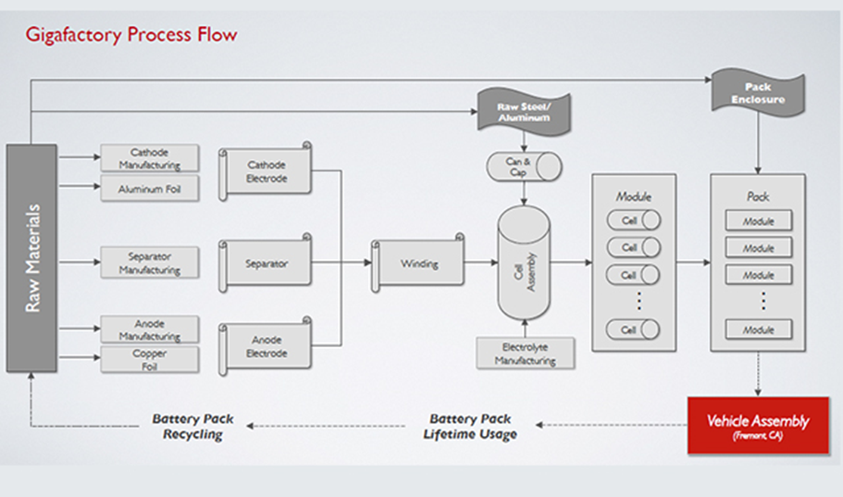

Everything that goes into a Tesla Automobile is of the highest quality and backed fully by Elon Musk himself. Tesla knows its value chain granting it the ability to offer an incredible 8 year infinite mile battery warranty assuring the customer quality and lasting value of their vehicles.

The primary activities and secondary activities are important to the success of Tesla. The primary activities (Inbound Logistics, Outbound Logistics, Operations, Marketing and Sales, and Service) allow Tesla to provide products for their customers with high quality. The secondary activities (Firm Infrastructure, Technological Development, Human Resource Management, and Procurement) help them meet the goals of the primary activities. Both the primary and the secondary activities of Tesla give value to the company, the overall mission, and competitive advantage in making the high quality electric vehicles.

Figure 5 shows the primary and secondary activities of Tesla Motors.

**Figure 5:**



Figure 6 shows the supplers to Tesla Motors 2013 Model S by part.

**Figure 6:**

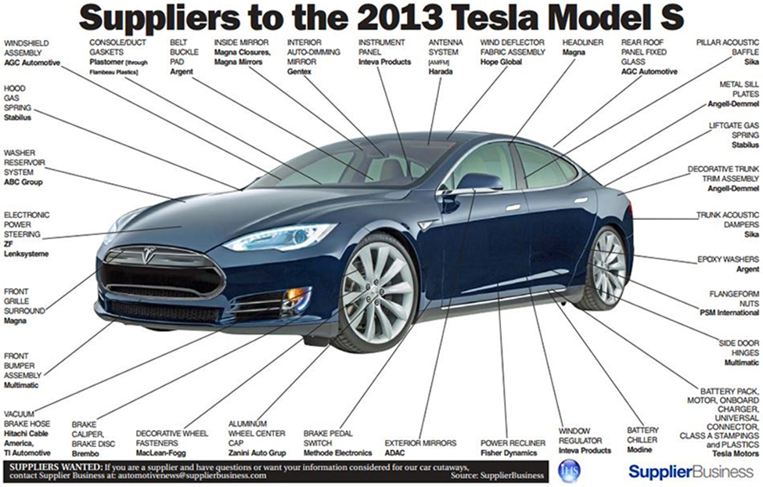

**Financial Analysis**

**Risk factors**

In the most recent Annual report, December 2014, submitted to the United States Security and Exchange Commission, by Tesla Motors, Tesla has disclosed some risk factors, for the company. Tesla has come across these risk factors in producing the electric vehicles.

Tesla has seen recent delays and complications in bringing new vehicles to the market. An example used is the new model X, expected to be out in 2015’s third quarter, Tesla reports that there is ongoing development and testing that could result in a delay of model X’s release. Complications are also foreseen to come from other factors including expansion of production capabilities, finalization of the supply chain, and completion of regulatory approvals needed. Suppliers may also be a factor of complication with speed, price, or even quantities of materials needed. Problems with the new Gigafactory, could negatively affect Tesla. Tesla intends to build the lithium-ion cells and finished battery packs for its vehicles in these Gigafactories to reduce costs of cell production and be able to produce these cells in a volume that will allow Tesla to grow quickly. (Deepak)

“Our long-term success will be dependent upon our ability to design, build and achieve market acceptance of new vehicle models. Moreover, there can be no assurance that we will be able to design future electric vehicles that will meet the expectations of our customers or that our future models, including the Model X crossover, will become commercially viable.” (Deepak)

Tesla knows that if the powertrains fail to perform as expected or if recalls are necessary its ability to sell electric vehicles could be damaged. Tesla’s design is highly dependent on software to operate it. These types of products are extremely complex and could have defects and errors. Tesla has already seen some of these defects in an earlier model. (Deepak)

“Any product defects or any other failure of our performance electric vehicles to perform as expected could harm our reputation and result in adverse publicity, lost revenue, delivery delays, product recalls, product liability claims, harm to our brand and reputation, and significant warranty and other expenses, and could have a material adverse impact on our business, financial condition, operating results and prospects.” (Deepak)

Tesla also figures in risk factors of potential customers. The only way for Tesla to make money is to sell the vehicles produced. “If the market for electric vehicles in North America, Europe and Asia does not develop as we expect, or develops more slowly than we expect, our business, prospects, financial condition and operating results will be harmed. The market for alternative fuel vehicles is relatively new, rapidly evolving, characterized by rapidly changing technologies, price competition, additional competitors, evolving government regulation and industry standards, frequent new vehicle announcements and changing consumer demands and behaviors.” (Deepak)

Some Other factors that may influence the adoption of alternative fuel vehicles, and specifically electric vehicles, include but are not limited to:

* perceptions about electric vehicle quality, safety (in particular with respect to lithium-ion battery packs), design, performance and cost, especially if adverse events or accidents occur that are linked to the quality or safety of electric vehicles, such as those related to the Chevrolet Volt battery pack fires or incidents involving Model S
* Perceptions about vehicle safety in general, in particular safety issues that may be attributed to the use of advanced technology
* Negative perceptions of electric vehicles, such as that they are more expensive than non-electric vehicles and are only affordable
* The limited range over which electric vehicles may be driven on a single battery charge and the effects of weather on this range
* Concerns about electric grid capacity and reliability, which could derail our past and present efforts to promote electric vehicles as a practical solution to vehicles which require gasoline;
* The availability of alternative fuel vehicles, including plug-in hybrid electric vehicles;
* The availability of service for electric vehicles
* The environmental consciousness of consumers;
* Government regulations and economic incentives promoting fuel efficiency and alternate forms of energy as well as tax and other governmental incentives to purchase and operate electric vehicles
* Access to charging facilities, standardization of electric vehicle charging systems and consumers’ perceptions about convenience and cost to charge an electric vehicle
  + (Deepak)

**Financial Data**

In 2014, Tesla Motors had revenues of 3198 million dollars, cost of goods sold of 2317 million dollars, and a gross profit of 882 million dollars. This was not enough to keep Tesla’s net income in the positive. In 2014, Tesla had a net income of -294 million dollars. In fact, Tesla has had a negative net income for the past five years. Tesla has a high level of expenses compared to its sales. The profit margin of sales from Tesla for the past five years has been pretty steady except for the decline in 2012. (Morningstar) (Deepak)

Figure 7 shows the revenues, costs of goods sold and gross profit compared throughout the last five years.

**Figure 7:**

(Morningstar) (Deepak)

Profit margin is calculated by taking the gross profit and dividing it by the revenues. The profit margin for a company is a good thing to look at because we can look at earnings, weather the increase or decrease, but an increase does not mean that the profit margin of Tesla is improving. When we look at the profit margin, we learn how much out of every dollar of sales Tesla is actually getting to keep. With this information we can then compare Tesla to other companies and see which company is making more on sales.

Figure 8 shows the profit margin of Tesla over the past five years.

**Figure 8:**

(Morningstar) (Deepak)

In October 2012, Tesla completed a follow-on offering of common stock in which a total of 7,964,601 shares of our common stock was sold and cash proceeds of $222.1 million received net of underwriting discounts and offering costs. ( Deepak)

In May 2013, Tesla completed a public offering of common stock and sold a total of 3,902,862 shares of common stock for total cash proceeds of approximately $355.1 million, net of underwriting discounts and offering costs. Tesla also sold 596,272 shares of common stock to the CEO and received total cash proceeds of $55.0 million in a private placement at the public offering price. (Deepak)

Figure 9, “The following graph shows a comparison from June 29, 2010 through December 31, 2014, of the cumulative total return for our common stock, the NASDAQ Composite Index, and a group of all public companies sharing the same SIC code as us which is SIC code 3711, “Motor Vehicles and Passenger Car Bodies” (Motor Vehicles and Passenger Car Bodies Public Company Group).” (Deepak)

**Figure 9:**

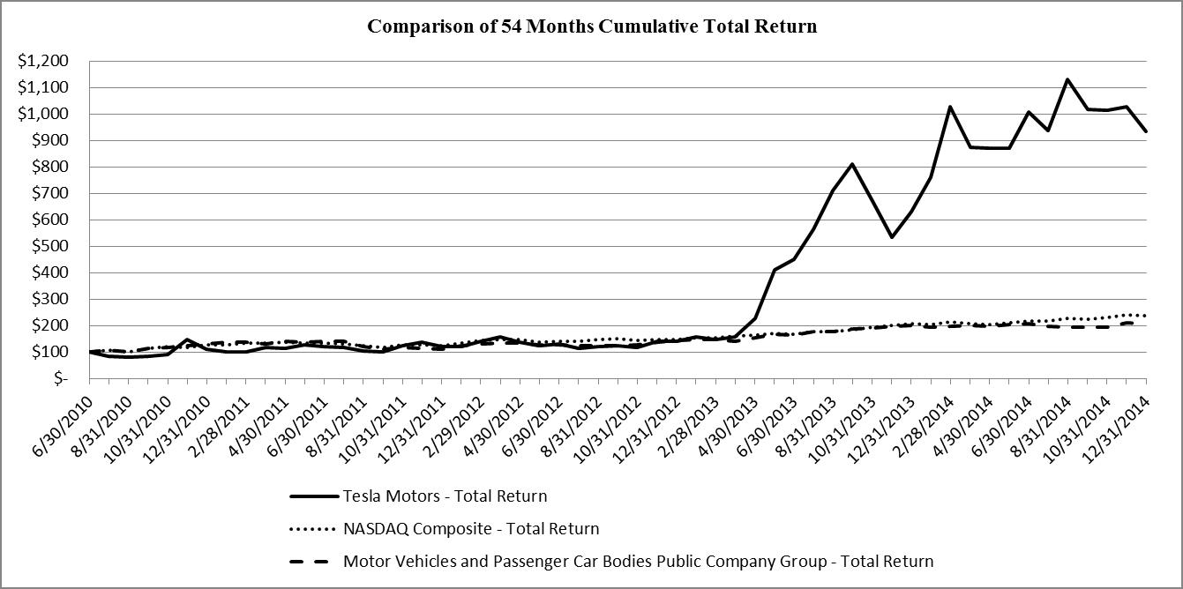

(Deepak)

**Strategic Alternatives**

Tesla is a global leader in clean energy technology and is spear heading the push for better and better fully electronic cars. With Tesla being such a young company and also being very technologically advanced, it’s very difficult to recommend more strategic alternatives to a company ran by Elon Musk. Tesla’s CEO Elon Musk has taken the clean energy of his cars and expanded it much further than just automobiles. His multiple companies expand on clean energy for rockets to space, residential home energy and even clean solar power grids for communities. My suggestions to the Tesla executives would be to further these explorations into advanced clean energy technology and use Tesla’s massive amount of resources and knowledge to expand world use of that clean energy.

First and foremost, Tesla is a great company because of their excellence in producing luxury electric vehicles. Strategic alternatives should focus on bettering the Tesla vehicle and the overall customer experience with the cars as that is what Tesla is built on. The newer models of cars are already very innovative with use of high quality electronics and many former Apple employees adding unique Apple-like touches to the cars. Added technology and innovation are a perfect fit for the Tesla brand and to remain relevant to the target group of buyers. Some added things that Tesla could do for their cars are similar to what Chevrolet is doing with wireless internet in the car. That’s an innovative step and for a luxury brand there needs to be luxury options.

Another thing that I feel the top management needs to consider is a greater expansion of car models. Tesla has revolutionized what a sedan can be with their original Model S and are soon to be expanding into SUV’s with their Model X. Now I feel in the five to eight year future Tesla needs to make a pickup truck. One of the most commonly purchased vehicles in the United States is pickups like the F-150 and Silverado. In order to capitalize on this market segment and completely revolutionize the industry, trucks need to be looked into as the upside for the company and our environment would be greatly increased. The potential for trucks working for governments and businesses would dramatically reduce fuel costs and overall costs to consumers and taxpayers. As the strong pickup truck platform becomes developed then the further expansion into commercial trucks can be explored. The upside of a shipping company with a fully electric fleet of trucks could revolutionize industrial America cutting harmful emissions and shipping costs dramatically. A Tesla line that provided the first of its kind commercial vehicles could have unlimited upside and with the space that is available in the current factory, these vehicles could be produced in the same place. With an expansion of the models and product line, a much greater infrastructure of charging stations would be needed and that is the next development the company will undertake.

A well-developed infrastructure needs to be the most immediate change this company tackles to make Tesla cars a feasible car for the mass production of the Model 3. Charging and battery changing stations need to be in a wide spread of locations in order to have a brand presence in the world that allows potential customers to see these stations repeatedly, assuring them a Tesla is a practical purchase for the future. A vast network of these stations, that are already far into development, make Tesla cars a much more practical purchase for people to justify as long trips and extended stays away from home would be possible.

One of the most important strategic alternatives that I feel Tesla could utilize is the development of a network of solar powered battery storage systems. Already in development with one of Elon Musk’s other companies he’s a board member of, Solar City, a solar panel that can collect solar energy and store it to power an entire home. This technology should be available to all customers of Tesla as a part of the buying process in order to give them the ability to have an incredible clean power source that can charge their cars. Widespread use of this technology can create an abundance of reusable energy that Tesla customers could utilize. The ultimate goal of this technology in homes across the world would be to eventually have infrastructure of reusable energy that could allow Tesla vehicles to be charged in as many places as gas stations today.

Even as successful and innovative as Tesla is, they currently don’t use any advertising method making it less known to the general public for the most part. Simple strategies such as media broadcasting would get their name out there to educate future customers, and make them more of a known competitor within the car industry. Tesla currently goes for more of an exclusive option for wealthier clients but to broaden their customer base, as they are planning on creating a line more affordable and attainable, advertising will be needed. When this line becomes available they will need to develop a marketing strategy to reach such customers and increase brand awareness that customers will also like.

One final strategic alternative for Tesla that is already in the works is an advancement of dealerships or more likely showrooms. This enables the customers to get a feel for the cars and physically see and drive them before they order. Everything currently is handled online; and, while that is a very progressive process that doesn’t need to change, people still like to an actual product before the purchase. This is a great way for Tesla to expand the brand name and allow more people to gain comfort with their cars.

Tesla is a vastly innovative company already making them the leader in so many aspects and technologies. Most importantly to the company, they need to continue to be on the cutting edge and create an atmosphere of futuristic cars to the customers. Tesla cars may be the future of the car industry so their best strategy is to remain that way.

**Value Curve**

The Value Curve analysis is one way to chart a profile of a firm's competitive factors that create value for the customers and compare the firm's position relative to its rivals. For Tesla the competitors we chose are the Nissan Leaf, the Chevy Spark and the BMW 13. The competitive factors that create value to the customers we chose are: price, range on charge, annual fuel costs, time for 1 full charge, and amount of cargo space.

Figure 10 shows the relative offering level of each competitive factor, shown as a range of 0-6 (6 being high and 0 being low)

**Figure 10:**

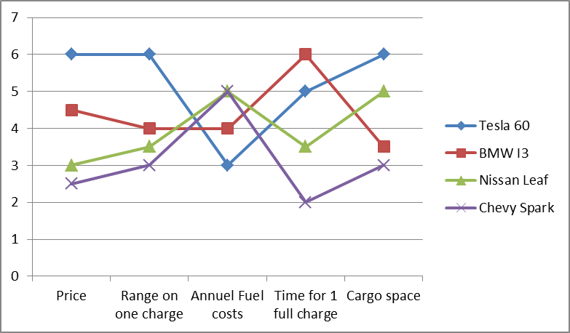

Figure 11 shows Tesla’s estimated cost, Range, fuel cost, charge time and cargo space compared to that of its competitors.

**Figure 11:**

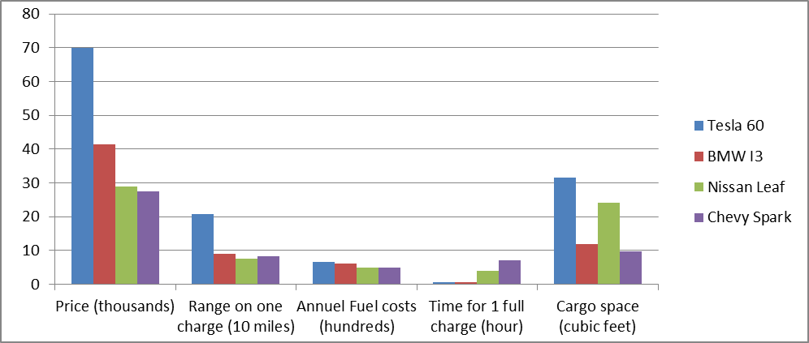

As shown by our graphs, Tesla sets itself apart from the competition in almost all aspects. The most significant differences we charted are the range of the battery pack and the horse power that Tesla brings to the table. The closest competitor, the BMW is short the standard Tesla Model S horsepower by about 200hp. This doesn't even consider the Tesla P85D Model S that can put out 691 Horsepower and a 0-60mph time of 3.2 seconds betting out gas powered Porsches and Dodge Chargers and competing with super car McLaren F1. That adds a whole new aspect to the value curve of Tesla that can't be compared to competition because there is simply no competitors in electric performance and the only competitors are gas powered performance cars. As for battery range against competitors, Tesla far exceeds competitors again with 100 mile greater range than the BMW. Overall, the value for the customer is very clear when you purchase a Tesla vehicle.

**Final Recommendations**

**Targets:**

1. Experience- Can the experience be better for Tesla customer?
2. Costs- Can costs be lowered anywhere in order for it to be more affordable and profits can still be made?
3. Profit- Can more money be made in the industry?
4. Can demand be increased?

**Measurable outcomes:**

1. **Experience- Can the experience be better for Tesla customers?**
   1. Short-term( less than 1 year)-
      1. Have car shows for the public
   2. Mid-Term (up to 5 year)-
      1. Develop more models
      2. Develop a plan to describe the safety features to customers to ease worries about safety
      3. Develop a plan to describe the battery features to customers to ease worries about batteries
   3. Long-Term (5-20 years)-
      1. Develop cost lowering strategies
2. **Costs- Can costs be lowered anywhere in order for it to be more affordable and profits can still be made?**
   1. Short-term ( less than 1 year)-
      1. Raise prices on services
      2. Match prices of competitors
   2. Mid-Term(up to 5 years)-
      1. Gigafactory will be done in 2016, this will lower outside vendor costs
   3. Long term (5-20 years)-
      1. Research materials
3. **Profit- Can more money be made in the industry?**
   1. Short-term ( less than 1 year)-
      1. Home battery systems
      2. Battery sales to other car manufactures
   2. Mid-Term(up to 5 years)-
      1. Develop and finish Gigafactories
   3. Long term (5-20 years)-
      1. Expand globally with Gigafactories
4. **Can demand be increased?**
   1. Short-term ( less than 1 year)-
      1. Increase Advertising (brand awareness)
      2. Have car shows for the public to view the new cars
   2. Mid-Term(up to 5 years)-
      1. Develop a weekend program for interested customers to try out a vehicle.
      2. Develop in a different market segment (not only the premium market)
      3. Get billboards in all major cities
   3. Long term (5-20 years)-
      1. Make a more affordable vehicle.
      2. Go global
      3. Add service stations in all major cities to show customers they will be covered if they want to travel

In conclusion, Tesla Motors is doing well by creating the Gigafactories. This step towards the future will help them to reduce costs and lead them to make money in other sectors. If Tesla wants to sell cars they will need to come up with ways to increase the brand awareness of the company. There are many people who have doubts about electric vehicles and this fear is one thing that negatively affects the sales of Tesla’s vehicles. If Tesla were to come up with a plan to show the cars to people or let people test the cars in advance more people might want to buy. As the current market is, tesla would need to become more competitive with pricing to have more buyers. There are many things Tesla is doing, with the Gigafactories, which will help this company in the long run.

We do not believe Tesla is in a bad place, but we think they could expand globally and try to target a larger market. This would be good for Tesla because there may be more people globally who are willing to try an electric vehicle with a large price tag.

**Bibliography**

Agassi, Shai. "Tesla's a Threat to the Auto Industry, But Detroit's Reacting All Wrong." The Huffington Post. TheHuffingtonPost.com, 19 Aug. 2013. Web. 06 Apr. 2015.

Ahuja, Deepak. "Tesla Motors - Annual Report." Tesla Motors - Annual Report. N.p., 7 Mar. 2013. Web. 06 Apr. 2015.

Alspach, Kyle. "Can Gas Vehicles Survive Elon Musk's Next Announcement?" BostInno. N.p., 26 Dec. 2014. Web. 06 Apr. 2015.

Baer, Drake. “The Making of Tesla: Invention, Betrayal, And The Birth of The Roadster”, *Business Insider.* Nov 11, 2014. *<*[http://www.businessinsider.com/tesla-the-origin-story-2014-1*0*](http://www.businessinsider.com/tesla-the-origin-story-2014-10)*>*

Biello, David. "Should Battery Fires Drive Electric Cars Off the Road?" Scientific American Global RSS. N.p., 12 Nov. 2013. Web. 06 Apr. 2015.

Blanc, Martin. "Tesla (TSLA) to Solve Battery Problems by Building the World's Largest Battery Factory." Business and News RSS. N.p., 24 Feb. 2014. Web. 06 Apr. 2015.

Cain, Steffani. "GOOD CAR BAD CAR." USA Auto Sales Brand Rankings. N.p., 1 Apr. 2015. Web. 06 Apr. 2015.

Carpenter, Mason A.; Wm. Gerard Sanders. 2009 “Strategic Management: A Dynamic Perspective Concepts and Cases, Second Edition” Retrieved March 2015.

Cheredar, Tom. "Tesla Plans to Produce over 35,000 Electric Vehicles This Year, 100K By 2015." VentureBeat. N.p., 31 July 2014. Web. 06 Apr. 2015.

*ConsumerReports.org* “Would you buy your car again?” Dec. 2014. <<http://www.consumerreports.org/cro/2012/12/owner-satisfaction/index.htm>>

Deepak, Ahuja. Chief financial officer “Tesla” February 2015. Web. http://ir.teslamotors.com/secfiling.cfm?filingid=1564590-15-1031&cik=#TSLA-10K_20141231_HTM_ITEM_6 .Retrieved March 2015

Draughon, Jarrod. “Chapter 5-Evaluating the Firm’s strengths and Weaknesses, ”Sept 2014. <https://jddrghon.wordpress.com/2014/09/>

Fehrenbacher, Katie. "Tesla Confirms Huge Battery Factory Plan, Will Ship 35K Model S Cars This Year." Gigaom. N.p., 19 Feb. 2014. Web. 06 Apr. 2015.

Loveless, Bill. "Former Oil Exec: $5-a-gallon Gas on the Way." USA Today. Gannett, 20 Jan. 2015. Web. 06 Apr. 2015.

Morningstar, 2015. “Tesla Motors Inc.Web. http://financials.morningstar.com/income-statement/is.html?t=TSLA&region=usa&culture=en-US .Retrieved March 2015

Noland, David. "How To Cut The Line And Get A Tesla Model S Right Away." Business Insider. Business Insider, Inc, 02 May 2013. Web. 06 Apr. 2015.

Rosevear, John. “Why Tesla Motors’ High Customer Satisfaction Rating Isn’t All Good News”. Dec 9, 2014. <<http://www.fool.com/investing/general/2014/12/09/why-tesla-motors-high-customer-satisfaction-rating.aspx>>

Russo, Edward. "Public Electric-car Charging Stations Sit Idle Most of Time." The Seattle Times. N.p., 05 Jan. 2015. Web. 06 Apr. 2015.

Rutterl, Tamara. "Why Tesla Has the Most Loyal Customers." USA Today. Gannett, 06 Sept. 2014. Web. 06 Apr. 2015.

Schaal, Eric. "The 10 Electric Vehicles With the Longest Driving Range." The Cheat Sheet. N.p., 16 Jan. 2015. Web. 06 Apr. 2015.

Shahan, Zachary. "Wow — Only 22% Of Public Knows About Tesla Model S, Only 31% Familiar With Nissan Leaf." CleanTechnica. N.p., 29 Nov. 2013. Web. 06 Apr. 2015.

Tesla. "About Tesla." About Tesla. Tesla Website, 06 Apr. 2015. Web. 06 Apr. 2015.

Tesla. "Incentives." Electric Vehicle. N.p., 06 Apr. 2015. Web. 06 Apr. 2015.

“Tesla Motors-Five Forces Analysis”< <http://www.wikiwealth.com/five-forces:tesla-motors>>

“Tesla Releases Fourth Quarter and Full Year 2014 Financial Results”. Feb. 11, 2015.< [http://ir.teslamotors.com](http://ctt.marketwire.com/?release=1174219&id=5393431&type=1&url=http%3a%2f%2fir.teslamotors.com%2f)> . Retrieved March 2015

Weiss, Geoff. "Elon Musk Threatens Layoffs After Tesla Sold Just 120 Cars in China Last Month." Entrepreneur. N.p., 11 Feb. 2015. Web. 06 Apr. 2015.

Wood, Laura. "Global Battery Electric Vehicles Market 2015-2019 with BMW, Daimler, General Motors, Mitsubishi Motors, Nissan Motor, Renault & Tesla Motors Dominating." Global Battery Electric Vehicles Market 2015-2019 with BMW, Daimler, General Motors, Mitsubishi Motors,... N.p., 11 Feb. 2015. Web. 06 Apr. 2015.

Zack, George. "The Gigafactory Will Lend Tesla A Cost Advantage; Or Will It?" Business and News RSS. N.p., 03 Sept. 2014. Web. 06 Apr. 2015.